**AZURE STORAGE** – 4th September 2023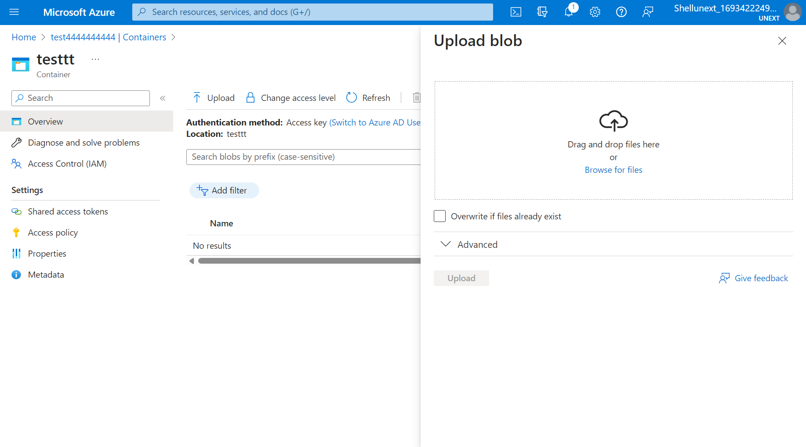

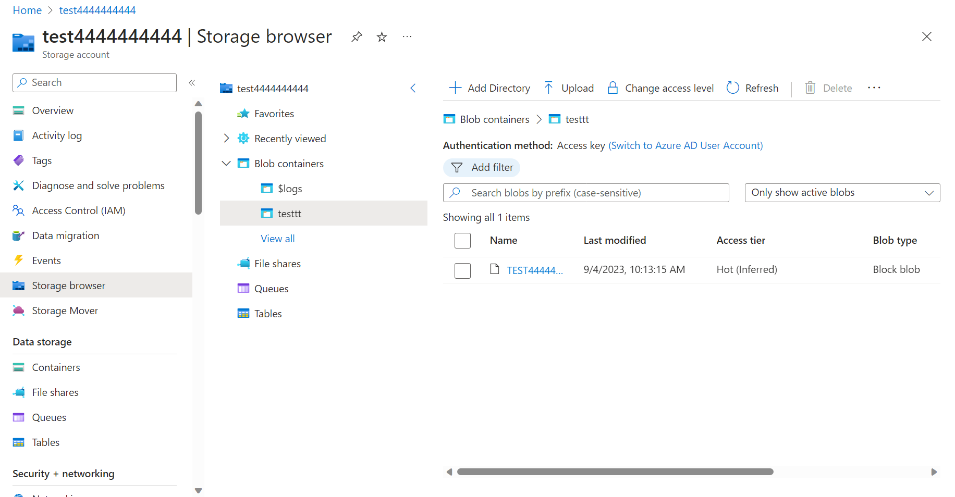

**File Storage:**File storage or file level storage is the data stored as a single piece of information inside a folder.

**Block Storage:** It chops data into blocks and stores them as different pieces. Each block of data is given a unique identifier, which allows the storage system to place the smaller pieces of data wherever it is convenient.

**Object Storage:**Is a flat structure in which files are broken into pieces and spread out among hardware. In object storage, data is broken into different units called objects and it’s kept in a single repository instead of being kept as files in folders or as blocks on servers. Object storage requires a simple HTTP programming interface which is used by most clients in all languages.

[File storage, block storage, or object storage? (redhat.com)](https://www.redhat.com/en/topics/data-storage/file-block-object-storage)

Azure Storage access tiers include:

* **Hot tier** - An online tier optimized for storing data that is accessed or modified frequently. The hot tier has the highest storage costs, but the lowest access costs.
* **Cool tier** - An online tier optimized for storing data that is infrequently accessed or modified. Data in the cool tier should be stored for a minimum of **30** days. The cool tier has lower storage costs and higher access costs compared to the hot tier.
* **Cold tier** - An online tier optimized for storing data that is infrequently accessed or modified. Data in the cold tier should be stored for a minimum of **90** days. The cold tier has lower storage costs and higher access costs compared to the cool tier.
* **Archive tier** - An offline tier optimized for storing data that is rarely accessed, and that has flexible latency requirements, on the order of hours. Data in the archive tier should be stored for a minimum of 180 days.

Azure Queue storage is a service for storing large numbers of messages. You access messages from anywhere in the world via authenticated calls using HTTP or HTTPS. A queue message can be up to 64 KB in size. A queue may contain millions of messages, up to the total capacity limit of a storage account. Queues are commonly used to create a backlog of work to process asynchronously.

**Static Website 🡪** [microo (windows.net)](https://test4444444444.z13.web.core.windows.net/)

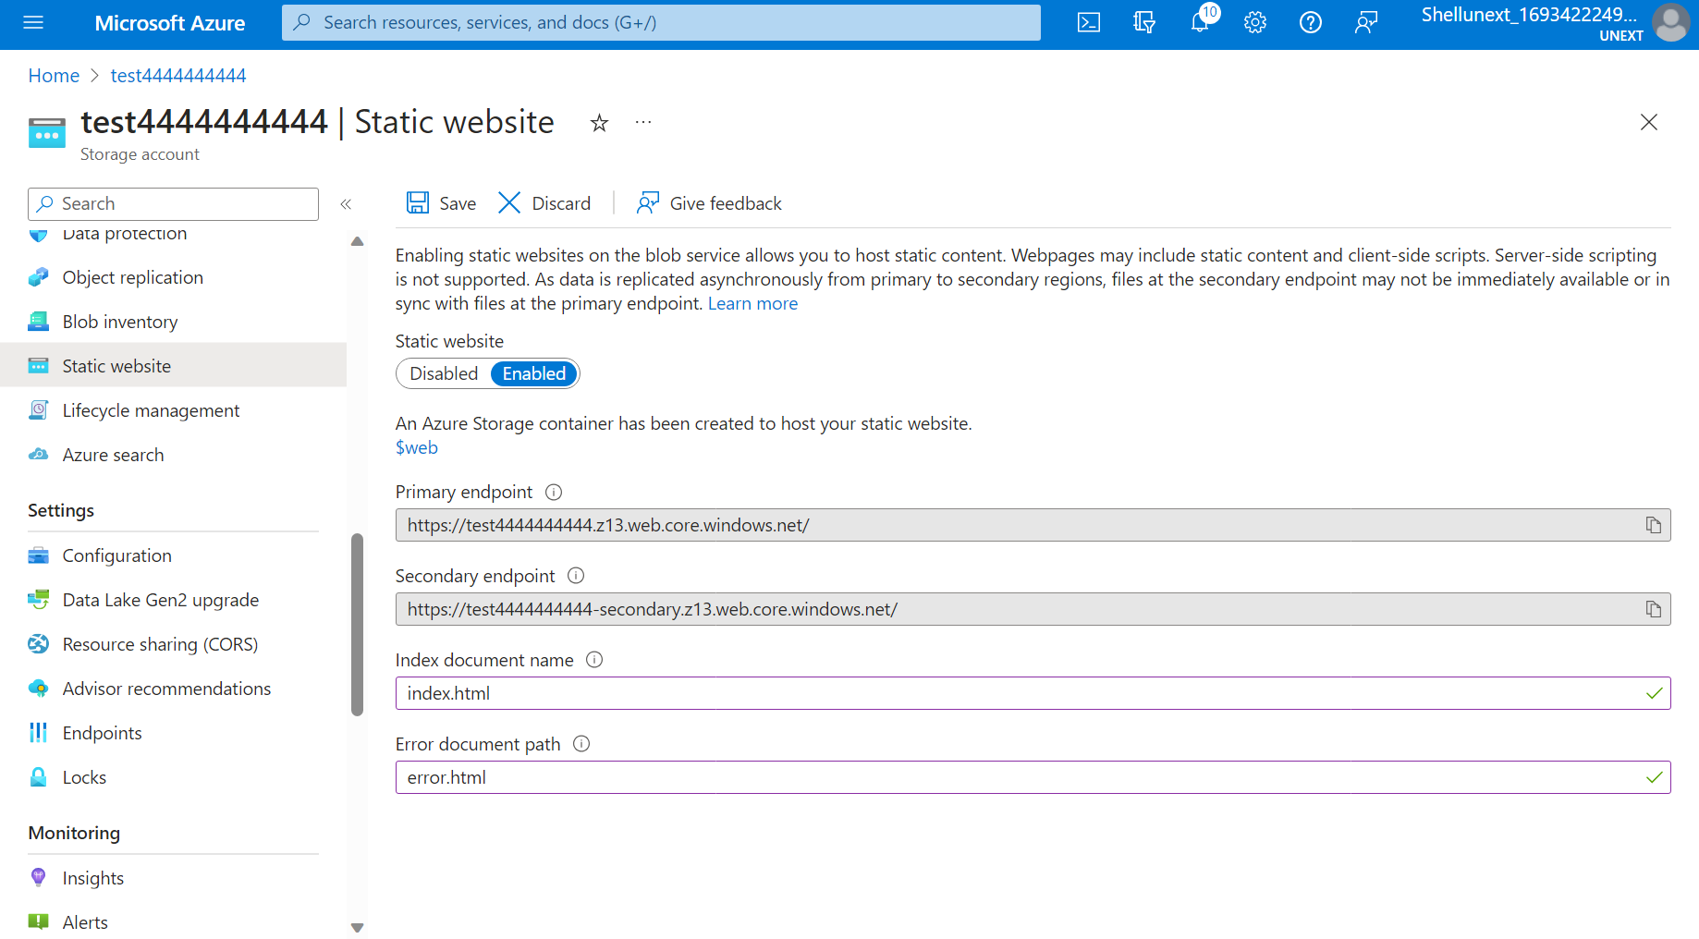

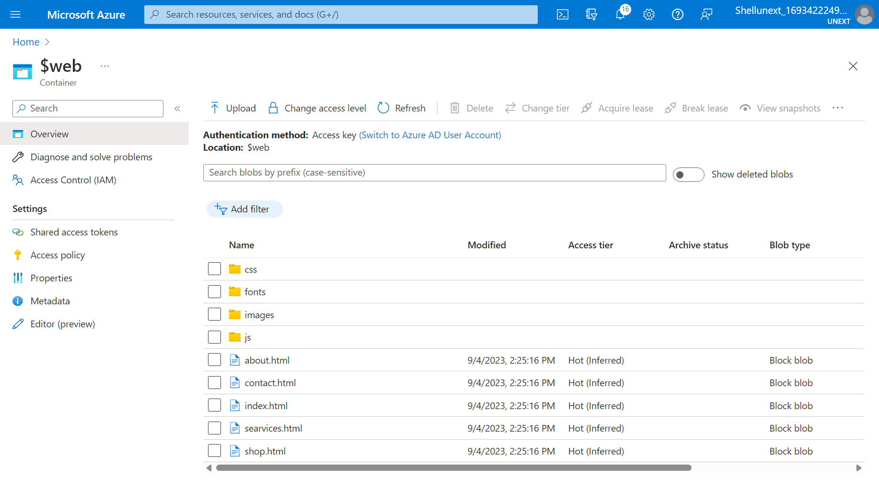



**2nd Website 🡪https://test8888888888888888888.z13.web.core.windows.net/**

**New storage account**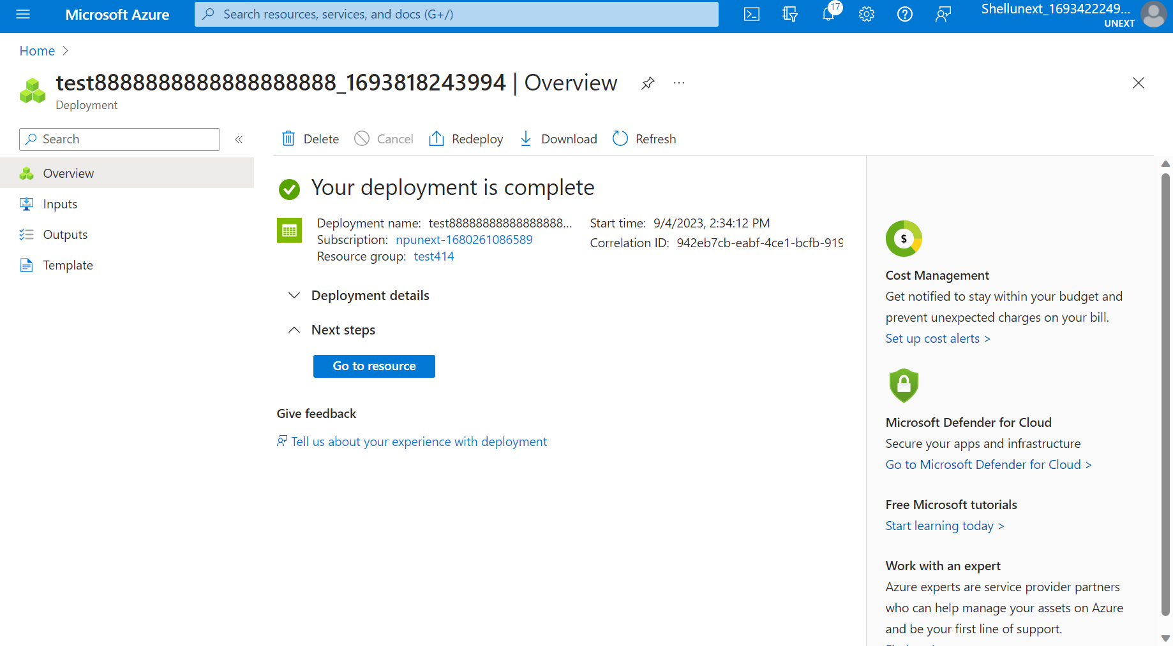

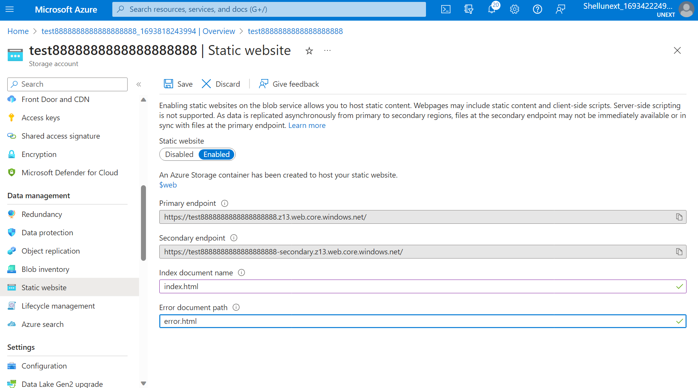

**DATA LAKE:**

Enable hierarchal namespace for storage account in advanced settings while creating storage account.

